EUROPEAN UNION

DELEGATION TO THE REPUBLIC OF RWANDA

The Head of Delegation

Kigali, 04 J AN - 7“

EEAS/ADV/PM/D (2016) 7899576

**Hon. Geraldine MUKESHIMANA**

**Minister of Agriculture and Animal Resources**

**P.O Box 621**

**Kigali**

**Subject: Endorsement of the GAFSP Project Proposal**



Honourable Minister,

On behalf of the Agriculture Sector Working Group (ASWG), I would like to thank you for sharing with us Rwanda's Funding Proposal to the Global Agriculture and Food Security Program (GAFSP).

We acknowledge that the proposal builds upon the achievements so far of the Government of Rwanda's Strategy for the Transformation of Agriculture (PSTA III) and associated Agriculture Sector Investment Plan (ASIP II); and contributes to reaching and sustaining the expected final outcomes of the Strategy implementation.

We support this proposal and wish you the best of success with your application.

Yours sincerely,

- Hon. Minister of Finance and Economic Planning

- Hon. Minister of State in charge of Agriculture

- Permanent Secretary - MINAGRI

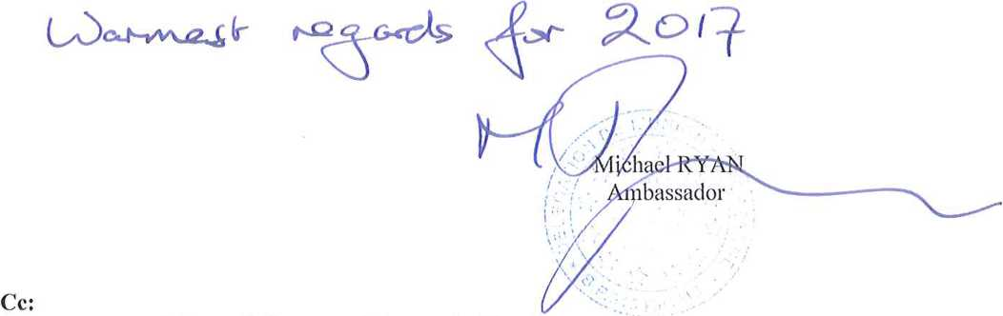

TEL: (250) 252 585 738 /39 MO FAX: (250) 252 585 734

1807, Boulevard de I'Umuganda - P.O.Box 515 KIGALI - RWANDA

E-Mail: [DELEGATION-RWANDA@eeas.europa.eu](mailto:DELEGATION-RWANDA@eeas.europa.eu)